1. **Define Kalman Filtering**

Kalman filtering is an **algorithm** used to estimate the state of a dynamic system from noisy measurements. It is widely applied in control systems, robotics, signal processing, computer vision, and navigation systems.

**Key Features:**

1. **Optimal Estimation**: Provides estimates of the system state that minimize the mean square error.
2. **Recursive**: Can update the estimates incrementally as new data becomes available, rather than requiring a batch of data.
3. **Real-Time Capability**: Efficient for systems where real-time updates are essential.

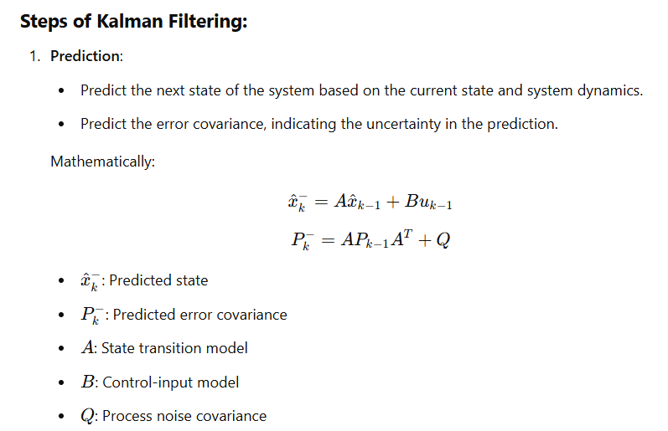

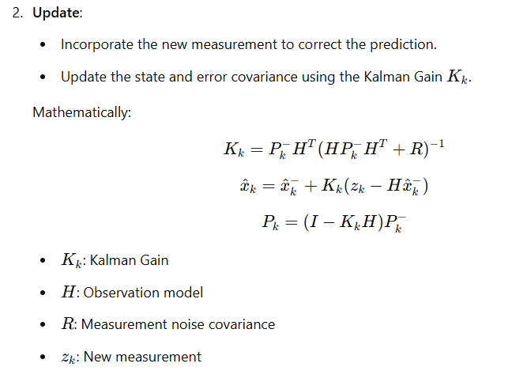**2.Difference Between Kalman Filtering and Gaussian Filtering with suitable examples**

| **Aspect** | **Kalman Filtering** | **Gaussian Filtering** |
| --- | --- | --- |
| **Purpose** | Estimates the state of a dynamic system over time by combining predictions and noisy measurements. | Smooths images by reducing noise and blurring using a Gaussian kernel. |
| **Input Type** | Works with time-series data or measurements from dynamic systems (e.g., sensor data). | Works with spatial data, such as images. |
| **Application Domain** | Applied in control systems, robotics, navigation, and computer vision for tasks like tracking and prediction. | Used in image processing to denoise and smooth images. |
| **Mathematical Model** | Combines system dynamics with measurements using recursive updates (Prediction-Update cycle). | Applies a Gaussian kernel (matrix) over the image to compute a weighted average of pixel intensities. |
| **Adaptivity** | Adaptive: Adjusts predictions dynamically based on new measurements. | Non-Adaptive: Applies the same Gaussian kernel throughout the image. |
| **Noise Handling** | Handles time-varying noise in dynamic systems. | Handles static noise in spatial data (e.g., random pixel variations). |
| **Complexity** | Computationally intensive; involves matrix operations like inversion, making it suitable for real-time but constrained by system complexity. | Less computationally intensive; primarily involves convolution operations. |

### ****Examples****

#### **1. Kalman Filtering Example**:

**Use Case**: Object Tracking in Video

* Suppose you're tracking a moving object in a video, such as a car.
* Measurements from a sensor (e.g., camera) are noisy due to environmental factors.
* 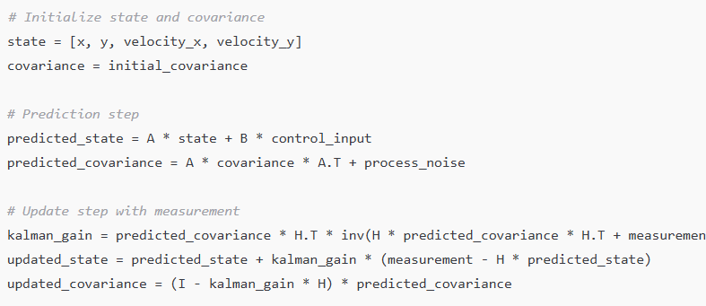Kalman Filtering predicts the car's next position based on its current velocity and previous positions while correcting for noise in the sensor data.

#### **2. Gaussian Filtering Example**:

**Use Case**: Image Smoothing

* Given an image with noise, a Gaussian filter can smooth it by convolving a Gaussian kernel with the image.
* This removes high-frequency noise and enhances the image's overall quality.

#### Pseudocode:

python

Copy code

import cv2

# Load image

image = cv2.imread('noisy_image.jpg', cv2.IMREAD_GRAYSCALE)

# Apply Gaussian filter

smoothed_image = cv2.GaussianBlur(image, (5, 5), sigmaX=1.0, sigmaY=1.0)

# Save or display the output

cv2.imwrite('smoothed_image.jpg', smoothed_image)

**3.Explain any 5 applications of Kalman filtering.**

**Applications of Kalman Filtering:**

**1. Object Tracking**

* **Description**: Kalman filtering is used to track moving objects, such as vehicles or people, in video sequences or real-world environments.
* **How It Works**: The filter predicts the next position of the object based on its current state (position and velocity) and corrects the estimate using sensor measurements.
* **Example**: Tracking a car in a traffic monitoring system by combining GPS data and visual input from cameras.

**2. Navigation Sytems**

* **Description**: Kalman filtering is central to modern navigation systems like GPS, aircraft navigation, and autonomous vehicles.
* **How It Works**: It combines noisy sensor data (e.g., GPS coordinates and inertial measurements) to estimate the vehicle's precise position and velocity.
* **Example**: In autonomous drones, Kalman filtering helps in stabilizing flight by predicting the drone's orientation and location

**3. Sensor Fusion**

* **Description**: Multiple sensors often provide complementary data for a system, and Kalman filtering merges these noisy measurements to get an accurate estimate.
* **How It Works**: Each sensor's output is treated as a noisy measurement, and the filter weights their contributions based on uncertainty.
* **Example**: Combining radar, lidar, and camera data in self-driving cars to detect and predict the positions of nearby objects.

**4. Economics and Finance**

* **Description**: Kalman filtering is used in forecasting and estimating economic indicators like stock prices, interest rates, and market trends.
* **How It Works**: The algorithm predicts future values based on past trends and adjusts estimates as new data becomes available.
* **Example**: Estimating the real-time GDP growth rate by combining different noisy economic signals.

**5. Robotics**

* **Description**: Kalman filtering helps robots understand and interact with their environment by estimating their position, orientation, and velocity.
* **How It Works**: The filter integrates data from sensors such as accelerometers, gyroscopes, and cameras to predict the robot's state in real time.
* **Example**: In robotic arms, Kalman filtering improves precision in tasks like assembling components or painting.

**4.Write an algorithm for Kalman Filtering and implement it using suitable example.**

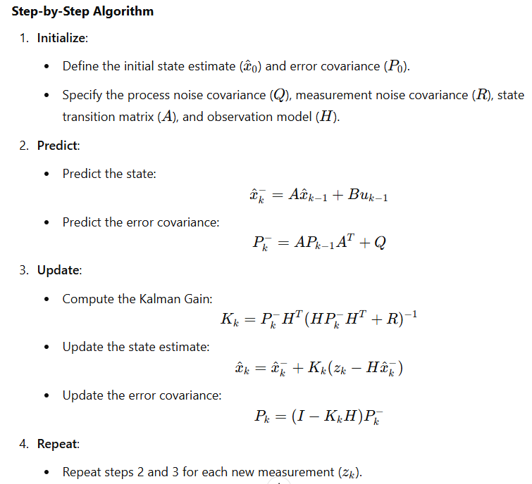

**Python Implementation**

**Example: Tracking the Position of a Moving Object**

python

Copy code

import numpy as np

# Initialize parameters

A = np.array([[1, 1], [0, 1]]) # State transition matrix

H = np.array([[1, 0]]) # Observation model

Q = np.array([[1, 0], [0, 1]]) # Process noise covariance

R = np.array([[5]]) # Measurement noise covariance

P = np.array([[1, 0], [0, 1]]) # Initial error covariance

x = np.array([[0], [1]]) # Initial state (position=0, velocity=1)

# Measurements (positions observed at each time step)

measurements = [1, 2, 3, 4, 5.2, 6.5]

# Kalman Filter Algorithm

for z in measurements:

# Prediction step

x_pred = A @ x

P_pred = A @ P @ A.T + Q

# Kalman Gain

K = P_pred @ H.T @ np.linalg.inv(H @ P_pred @ H.T + R)

# Update step

z = np.array([[z]]) # Current measurement

x = x_pred + K @ (z - H @ x_pred)

P = (np.eye(2) - K @ H) @ P_pred

# Display results

print(f"Updated State: Position = {x[0, 0]:.2f}, Velocity = {x[1, 0]:.2f}")

**Explanation**

1. **Inputs**:
   * Initial state: Position and velocity of the object (xxx).
   * Measurements: Observed positions at different time steps.
   * Noise Covariances: QQQ (process noise) and RRR (measurement noise).
2. **Outputs**:
   * Predicted and updated position and velocity after each measurement.
3. **How It Works**:
   * The object’s position and velocity are predicted based on its previous state.
   * Noisy measurements are corrected using the Kalman Gain to refine the estimates.